**Blueprint Note:** The following assignment sheet language is provided to support instructors and GTAs implementing the Worknet option for project three. The suggested language includes project overview, project specifics, formatting, and due dates. If you are attempting to customize this template for your section(s) of ENGL1105, please download an editable version or create a copy (i.e., make sure you are working with your own version before attempting to apply customizations).

*As you customize the document, please remove this blueprint note and header* so that all text appears with consistent, intentional design choices, such as common typeface size and color scheme. In customizing the blueprint assignment sheet language, ensure that any customizations work toward the program outcomes for ENGL 1105 and the goals for each unit. Finally, be sure to include a separate rubric or a section below that clearly outlines how students’ projects will be assessed based on your expectations and requirements.

**Project #3: Worknets**

**Overview**

Researched academic sources are a mainstay of *many* academic disciplines. They are how academics account for research activity—posing difficult questions and detailing studies that seek to inform some research question, to share evidence, or to circulate findings.

Worknets introduces you to a method for reading and writing your way across *one* researched academic source and thereby accounting for its generative connections. Worknets help readers comprehend and remember the important parts of an article, but they also prompt new researchable questions that can lead to emerging research interests for the reader.

Importantly, worknets consist of a series of phases which expand upon the article’s discoverable ties to keywords, sources, authorship, and the world (time and place) in which it was written. We should think of worknets as helping us engage sources visually and in writing so that we are better able to use the source toward rhetorical invention. Worknets also help us grasp the rhetorical situation in which the article was produced—who wrote the article, what their purposes were, who the audience was, and how the article has circulated or been taken up.

**Choosing an Academic Article**

[Instructor choice required below]

Choose a researched academic article relevant to an area of your interest published since 1980. Or, select *one* of the articles in the list below to complete your worknets project [instructor provides ~5 article choices based on course inquiry topic].

**How To Make A Worknet**

| choric.png |
| --- |
| Figure 1: A completed worknet. |

Use Google Drawing (Insert→Drawing→New) to create your worknets. It might take some time to get familiar with the drawing tools; we will spend time in class practicing using the tools and creating the worknet phases. **Important: Be sure to save a version of the model *after* each phase so you can easily show its build-up.** Using a hub and spoke model, draw links from the central node (the article author, title, and year of publication) to a series of surrounding nodes. Create 4-5 nodes for each of the following four phases: ***semantic***, ***bibliographic,*** ***affinity-based***, and ***choric***. Be sure to complete ONE PHASE AT A TIME.

**Written Components**

**A written account (approximately 300-400 words) accompanies each visual phase.** That’s four phases, four accounts. Each written account addresses the choices you made in creating that phase of the worknet; responds to questions noted in association with each phase; and brings to light relevant noticings at that phase. Your completed project will also include an opening paragraph that introduces the article’s purpose, audience, and context using rhetorical terms and concepts we have discussed this semester (e.g., ethos, pathos, logos; kairos; rhetorical situation/ecology; audience, exigence, constraints, etc.) and a concluding paragraph in which you critically engage with the content and/or composition of the article. In total, the written components of the project (intro, four phases, conclusion) will be **1800-2400 words.**

**Introduction Paragraph**

In the opening paragraph(s) of your worknets project, introduce your chosen article, including the writer(s) name(s) and title of the article. Provide a summary of the argument and briefly discuss the article’s purpose, audience, and context using rhetorical terms and concepts we have discussed this semester (e.g., ethos, pathos, logos, kairos, rhetorical situation/ecology, audience, exigence, etc.).

**Phase 1: Semantic**

***Semantic***: concerns vocabulary—words and phrases that appear in the article itself and whose reference and meaning can be traced to peripheral ideas suited to further exploration. Whether you seek individual words or two-word phrases, **include the total count in parentheses** (i.e., the number of times the word/phrase appears in the article), and **select 4-5 key terms or phrases.** There are online tools to help with this, such as [Tagcrowd.com](https://tagcrowd.com/), [Voyant Tools](https://voyant-tools.org/), and the Online NGram Analyzer at <http://guidetodatamining.com/ngramAnalyzer/>. In the written account that goes with the semantic phase, discuss *at least two* of the following prompts:

* What do the terms mean, both in general and in the context of the article?
* Why are these terms important? How do they advance the rhetorical goals (including purpose) of the piece?
* How do the keywords favor a particular audience, showing that audience regard for forms of knowledge that are important to them?

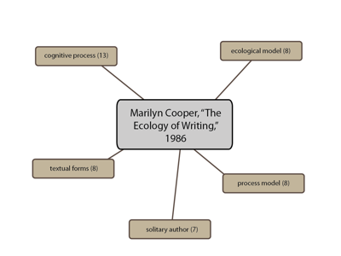

**Phase 2: Bibliographic**

***Bibliographic***: traces specific sources cited in the original. For this phase, turn to the works cited or references list at the end of the article. **Choose 4 sources.** In the written account that goes with this phase, discuss *at least two* of the following prompts:

* What are the dates of publication? Is this important for the meaning of the piece?
* How do the sources appear in the article? That is, how are they being used? Are they being critiqued or praised? Are they providing background information? etc.
* How might tracking down any one source expand your knowledge about the article and its rhetorical context?
* In what ways do specific sources advance the rhetorical goals of the piece?

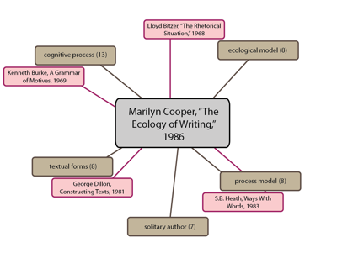

**Phase 3: Affinity-based**

***Affinity-based***: attends to functions of authorship, such as graduate training, collaborations, current position, career arc for publishing activity, and relationship to other specializations. For the affinity-based phase, look up the author. In the written account, discuss *at least two* of the following prompts:

* What else has the author written? What other work have they done?
* Do they publish by themselves or with others? Does it seem to you their other works are related to the focus of this article? How so?
* Where does the author work? How long have they worked there?
* How does the affinity phase give you a deeper sense of the author’s credibility, qualifications, or *ethos*?

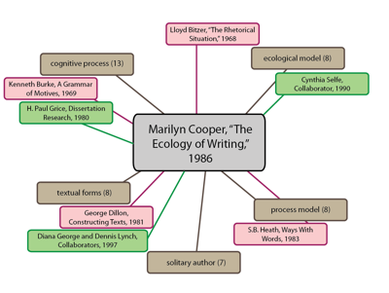

**Phase 4: Choric**

***Choric***: This phase examines the world in which the article was written, collecting a handful of pop culture references from the time and place it came from. Like the affinity worknet above, a choric worknet is not explicitly identifiable *in* the text of the article. It sets you up to explore events from popular culture (movies, songs, happenings, local and world news) in the interest of enlarging context and striking juxtaposition. In the written account, discuss *at least two* of the following prompts:

* What else, specifically, was happening when the article was written?
* What was going on in the place where it was written?
* How do a sample of these time-place associations open up new possibilities for exploring the article or an idea it introduces?

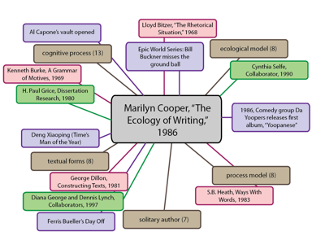

**Conclusion Paragraph**

In the final paragraph, *critically engage* with the content and/or composition of the article. Consider incorporating responses to *some* of the following questions for this paragraph.

* Where do you agree/disagree with the author, and why?
* Where is the author most/least convincing?
* How does the author encourage you to think differently about an issue?
* How does the author help you better support a position you already hold on the issue?
* Why does this article/argument matter? How does it relate to our conversations regarding language and/or writing?

**Formatting**

Your worknets project should:

* Be at least **1800 words.**
* Have **neat and purposeful** visual components.
* Have a **creative and fitting title** (something that describes your findings in analyzing the piece)
* Include an **MLA heading** (Name, Instructor’s Name, Course, Date) in the top left-hand corner.
* Use **purposeful** punctuation, grammar, and syntax to enhance your accounts.

**Due Dates**

* A half-draft of at least 900 words is due by the start of class on [DATE]
* A final draft of 1800-2400 words is due by the start of class on [DATE]